HBase Standalone Mode Installation on Ubuntu 14.04

Apache HBase is an open source, non-relational, distributed database modeled after Google's BigTable and is written in Java. It is developed as part of Apache Software Foundation's Apache Hadoop project and runs on top of HDFS (Hadoop Distributed File System), providing BigTable-like capabilities for Hadoop. That is, it provides a fault-tolerant way of storing large quantities of sparse data (small amounts of information caught within a large collection of empty or unimportant data, such as finding the 50 largest items in a group of 2 billion records, or finding the non-zero items representing less than 0.1% of a huge collection).
Pre Requirements
1) A machine with Ubuntu 14.04 LTS operating system installed.
2) Apache HBase 1.2.3 Software (Download Here)
HBase Standalone Mode Installation
This post describes setup of a standalone HBase instance that uses the local filesystem. It leads you through creating a table, inserting rows via the HBase shell, and then cleaning up and shutting down your standalone HBase instance.
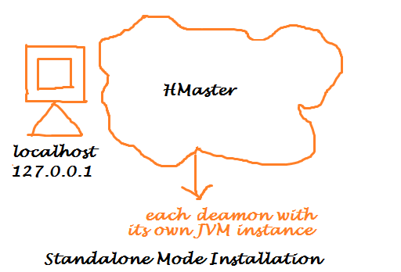
HBase Installation Steps
Step 1 - Installing java 7. Open a terminal (CTRL + ALT + T) and type the following sudo command.
$ sudo apt-get install openjdk-7-jdk
Verify Installation
$ java -version
Step 2 - Edit /etc/hosts file.
$ sudo gedit /etc/hosts
/etc/hosts file. Add machine IP address and hostname. Save and close.
127.0.0.1 localhost
127.0.0.1 praveen
Step 3 - Creating /usr/local/hbase directory.
$ sudo mkdir /usr/local/hbase
Step 4 - Change the ownership and permissions of the directory /usr/local/hbase. Here 'hduser' is an Ubuntu username.
$ sudo chown -R hduser /usr/local/hbase
$ sudo chmod -R 755 /usr/local/hbase
Step 5 - Creating /var/hbase/pids directory.
$ sudo mkdir /var/hbase/pids
Step 6 - Change the ownership and permissions of the directory /var/hbase/pids. Here 'hduser' is an Ubuntu username.
$ sudo chown -R hduser /var/hbase/pids
$ sudo chmod -R 755 /var/hbase/pids
Step 7 - Change the directory to /home/hduser/Desktop , In my case the downloaded hbase-1.2.3-bin.tar.gz file is in /home/hduser/Desktop folder. For you it might be in /downloads folder check it.
$ cd /home/hduser/Desktop/
Step 8 - Untar the hbase-1.2.3-bin.tar.gz file.
$ tar xzf hbase-1.2.3-bin.tar.gz
Step 9 - Move the contents of hbase-1.2.3 folder to /usr/local/hbase
$ mv hbase-1.2.3/* /usr/local/hbase
Step 10 - Edit $HOME/.bashrc file by adding the java and hadoop path.
$ sudo gedit $HOME/.bashrc
$HOME/.bashrc file. Add the following lines
export HBASE_HOME=/usr/local/hbase
PATH=$PATH:$HBASE_HOME/bin
export CLASSPATH=$CLASSPATH:/usr/local/hbase/lib/*
Step 11 - Reload your changed $HOME/.bashrc settings
$ source $HOME/.bashrc
Step 12 - Change the directory to /usr/local/hbase/conf
$ cd /usr/local/hbase/conf
Step 13 - Edit hbase-env.sh file.
$ gedit hbase-env.sh
Step 14 - Add the below lines to hadoop-env.sh file. Save and Close.
export JAVA_HOME=/usr/lib/jvm/java-8-openjdk-amd64
export HBASE_PID_DIR=/var/hbase/pids
Step 15 - Edit hbase-site.xml file.
$ gedit hbase-site.xml
Step 16 - Add the below lines to hbase-site.xml file. Save and Close.
<property>
<name>hbase.rootdir</name>
<value>file:///home/hduser/HBase/hbase</value>
</property>

<property>
<name>hbase.zookeeper.property.dataDir</name>
<value>/home/hduser/HBase/</value>
</property>
Step 17 - Change the directory to /usr/local/hbase/bin
$ cd /usr/local/hbase/bin
Step 18 - Start all hbase daemons.
$ ./start-hbase.sh
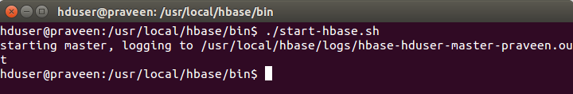
Step 19 - The JPS (Java Virtual Machine Process Status Tool) tool is limited to reporting information on JVMs for which it has the access permissions.
$ jps
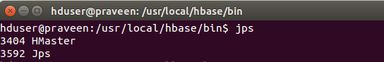
Once the HBase is up and running check the web-ui of the components as described below
http://localhost:16010
To Enter into HBase Shell
$ hbase shell
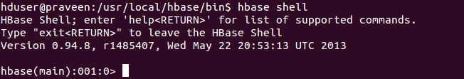
Step 20 - Stop all hbase daemons.
$ ./stop-hbase.sh


